FOR IMMEDIATE RELEASE

Difference makers: Anton Wörmann
The accidental activist
Who better to solve Japan’s problem of ‘akiya’ abandoned properties than a Swedish model and social media influencer? Yanmar CE talks to Anton Wörmann.
Anton Wörmann has a lot going for him – clever, cheerful, charming and – that dream of young people everywhere – a model AND social media sensation. As if all that weren’t enough, he has also, quite by accident, stumbled onto a solution to a pressing social problem in his adopted home of Japan: making the 10 million abandoned homes in the country cool.
Japan is an outlier in many ways, but the phenomenon of homes being left empty to fall into disrepair – even in exclusive areas of major cities – is uniquely Japanese. Known as ‘akiya’ (meaning ‘vacant homes’), their abandonment is the result of several factors, including Japan’s declining population, urbanisation, inheritance issues and simply Japan’s preference for all things new. Put simply, old buildings are not valued, not valuable – and certainly not cool.
Ready for take off
But that perception is starting to change – ever since 31 year old Anton, just for fun, started filming the renovation of his own akiya in 2020, and posting his triumphs and mishaps on social media. While doing up old properties is commonplace around the world, it’s virtually unheard of in Japan, so when Anton started publicising renovating his akiya – bought because it was cheaper than renting – it caused a sensation.
“I posted my first reel in English and just forgot about it,” says Anton. “Then a couple of days later a friend texted me from Paris to say ‘Hey dude – you’ve gone viral on TikTok! That was pretty cool – and within days I had 50,000 followers – and a million subscribers in a couple of months – which was insane! So I just carried on making content.”
Today, Anton has more than a million followers in total on Instagram, TikTok, Facebook and YouTube – with audiences of all ages drawn from the US, Europe – evenly split between men and women. What makes his content so popular is the compelling combination of learning about Japanese culture, the oddity of these properties being so cheap and Anton’s engaging and cheerful TV skills.
And in his spare time…
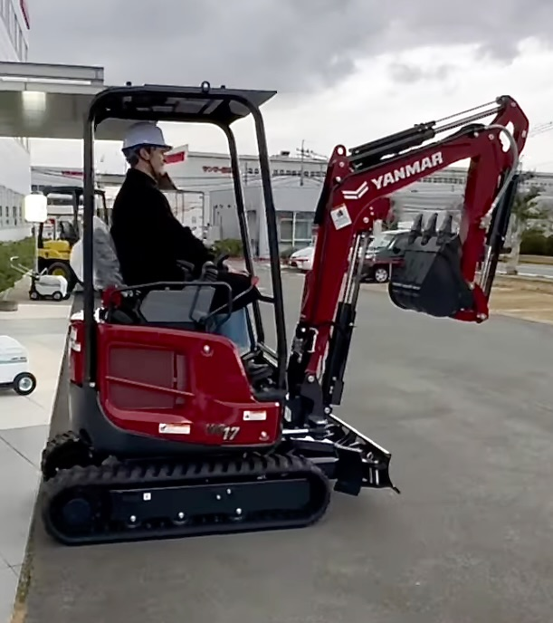
As his popularity grew Anton received thousands of comments and questions from viewers about how to renovate akiyas – too many for him to attempt to answer. So his response was to capture all his learnings in print and write a best selling book on the subject – called ‘Free houses in Japan’. Okay, so the houses aren’t free, but they can be bought for a fraction of what an equivalent property would cost anywhere else in the Western world.
As fun as it is to watch Anton’s adventures – he’s now on his fourth akiya – it has started to raise the profile of the very real – and growing – social problem akiya’s represent. (Their number is forecast to double to 20 million by 2030.)
“Japanese people love new things,” says Anton. “A house that is 30 or 40 years old is considered old – and unlike everywhere else in the Western World – their values don’t appreciate. In fact they fall until utlimately they are considered trash. Added to that, there is no renovation culture. Admittedly, many of them are ugly, but many are pretty – and I’ve even seen beautiful 150 year old townhouses abandoned. It’s really sad to see them so neglected.”
A more sustainable future
Anton doesn’t just return his akiyas to their previous state, he also makes them more sustainable; adding insulation, improving earthquake resistence and generally modernizing them – all the while retaining their special character. And as they still don’t have a high value even after restoratation, Anton hasn’t sold his renovated akiyas, but rather rents them out to tourists. All-in-all, he’s come a long way from being the boy who helped his parents renovate their 150 year old home in Stockholm, Sweden…
“I think my reels show that we don’t need to buy new-new-new all the time – with all the concrete and raw materials that go with it,” says Anton. We need to start valuing older homes – it’s a much more sustainable message and better for the planet. I’m happy to be a part of that movement. I didn’t expect any of it – it’s changed my life in so many ways.”
The likes of international investors and American documentary makers are all queueing up to support his efforts to save akiyas (even Yanmar CE lent him a compact excavator) – but is that what he really wants? Does he just want to be an influencer on social media – or would he rather be an activist that started a movement to save Japan’s unloved houses?

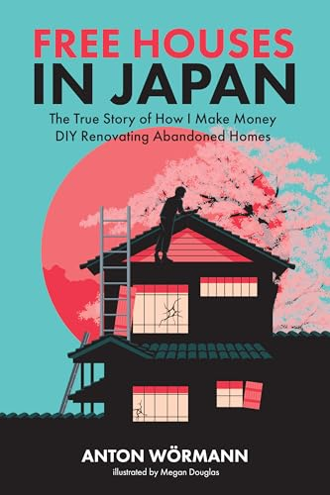
The unlikely radical
“What I’m doing is really not complicated – anyone could do it,” Anton says. “As long as I’m able to inspire people then I’m happy. I think someone needs to promote the many benefits of saving old houses, debunk the myths and show people how it can be done,” he says. “If people like what I do I’ll keep doing it. People in Japan and the Japanese media are starting to get interested – doing up akiyas is slowly becoming a thing. And in a strange way I think it needs to be a foreigner that shines a light on the great potential of saving old homes in Japan.”
With his popularity growing even Anton’s Japanese friends no longer think he’s crazy. While Do It Yourself renovation might not be the complete answer to Japan’s problem of abandoned homes, those that are renovated will help save resources and remove eyesores from local communities.
Ends.
Valeria Iervolino Brian O’Sullivan
Global Marketing & Communications PR support
Yanmar Compact Equipment Daredevil
valeria_iervolino@yanmar.com brian.osullivan@daredevilpr.com
+39 380 58 20 485 +44 77 333 50307

About Yanmar Compact Equipment

Yanmar Compact Equipment (Yanmar CE) is a global leader in the design, manufacture and support of compact equipment for a range of segments, principally construction and other earthmoving applications. Its products include extensive ranges of mini and midi excavators, wheel loaders, wheeled excavators, compact track loaders and tracked carriers. These are supported by a wide range of services designed to ensure customer success. A global company with proud Japanese heritage, Yanmar CE has manufacturing facilities in Asia, Europe and North America – and an extensive international dealer network. Renowned for its innovative approach – it was the first to market with the now-benchmark mini-excavator, and is credited with popularizing the zero-tail swing concept – Yanmar CE remains a trusted brand known for its reliability, performance and commitment to customer satisfaction. These traits are demonstrated through the company’s tagline – ‘Building with you’.
For more details, please visit the official website. https://www.yanmar.com/global/construction/

About Yanmar
With beginnings in Osaka, Japan in 1912, Yanmar was the first ever to succeed in making a compact diesel engine of a practical size in 1933. Moving on, with industrial diesel engines as the cornerstone of the enterprise, Yanmar has continued to expand its product range, services, and expertise to deliver total solutions as an industrial equipment

manufacturer. As a provider of small and large engines, agricultural machinery and facilities, construction equipment, energy systems, marine, machine tools, and components — Yanmar’s global business operations span seven domains.

On land, at sea, and in the city, Yanmar’s Mission of “providing sustainable solutions focused on the challenges customers face, in food production and harnessing power, thereby enriching people’s lives for all our tomorrows,” stands testament to Yanmar’s determination to provide us with “A Sustainable Future”.
For more details, please check out the official website of Yanmar Holdings Co., Ltd. http://www.yanmar.com/global/

